Online Banking Web Connect Conversion
QuickBooks Windows 2008-2011

As your financial institution completes its system conversion, you will need to modify your QuickBooks settings to ensure the smooth transition of your data. You will need to be able to log in to the Web site.

It is important that you perform the following instructions exactly as described and in the order presented. If you do not, your online banking service may stop functioning properly. This conversion should take about 15 minutes.

Note: The QuickBooks Windows Online Banking module has not changed. The product interface may look different; however the steps that follow will work for all versions of QuickBooks 2008-2011.

BACK UP YOUR CURRENT DATA

- Choose File menu → Back Up
- Specify which file to back up and where you want the backup saved in the QuickBooks Backup dialog, and then click OK

GET YOUR LATEST TRANSACTIONS

- Log in to your financial institution’s “old” Web site. Download your transactions into QuickBooks.



Important: You may not be able to download these transactions after the conversion.

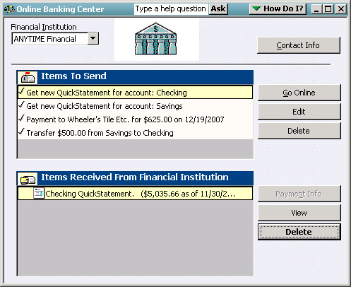
- Once in QuickBooks, view your downloaded transactions as usual. In the QuickBooks account register, add or match all transactions listed in the Downloaded Transactions tab. You will not be able to proceed until all transactions are matched.
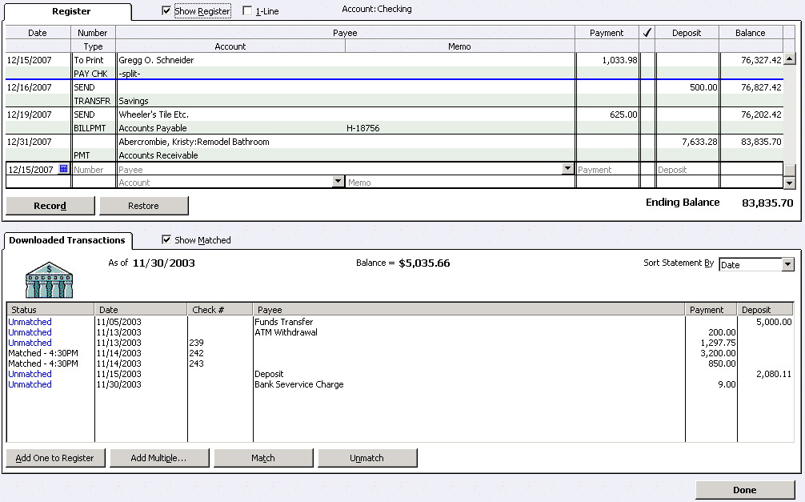

- Once all downloaded transactions are matched, click Done in the lower right.
- The Online Banking Center dialog displays. Click Delete to remove each item from the Items Received from Financial Institution section.
Repeat steps 1 through 4 for each account (such as checking, savings, and credit cards) that you plan to use for online banking.
For assistance reconciling your account register, choose Help menu → QuickBooks Help. In the Ask prompt, enter “reconcile your account”.

DEACTIVATE YOUR ACCOUNT FROM WEB CONNECT

- Choose Lists menu → Chart of Accounts
- Right-click your account
- Select Edit Account from the pop-up menu
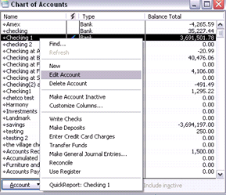

- In the Edit Account window, click the Online Services tab and choose Deactivate All Online Services
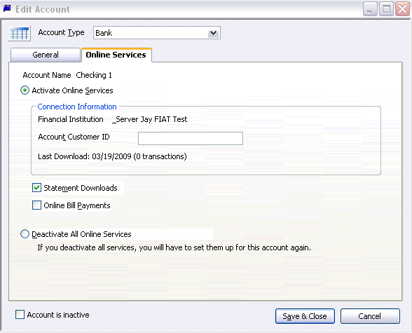

- Repeat steps 2 through 4 for each account from which you download transactions.

ACTIVATE YOUR ACCOUNT FROM WEB CONNECT

IMPORTANT: Do not complete this section until after the conversion.

- Log in to your financial institution’s Web site. Download your transactions into QuickBooks.

Important: To avoid the possibility of creating duplicate records when downloading into QuickBooks, select a “from” date that does not include records previously downloaded.
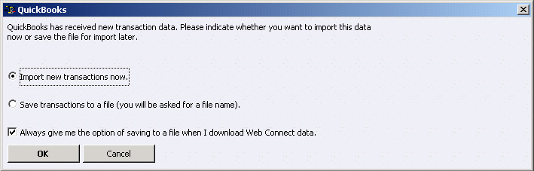
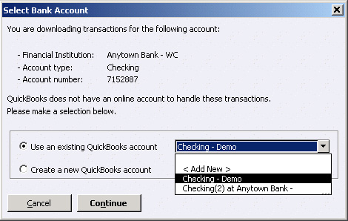

- In QuickBooks, click the Import new transactions now radio button. Then click OK.
Note: If you previously removed the check from the Always give me the option of saving to a file... option, then this dialog will not display.
- In the Select Bank Account dialog, click the Use an existing QuickBooks account radio button. In the corresponding drop-down list, select the QuickBooks account that you use. Click Continue.
Note: You only need to select the account for this first download. Future downloads apply to this account automatically.
- Confirm the prompt by clicking OK.
- Repeat steps 1 through 3 for each account that you previously disabled.
Verify that all transactions downloaded successfully into your account registers.

Thank you for making these important changes!

